**Week6 React HandsOn**

**3. ReactJS-HOL**

Create a react app for Student Management Portal named scorecalculatorapp and create a function component named "CalculateScore" which will accept Name, School, Total and goal in order to calculate the average score of a student and display the same.

Folder Structure

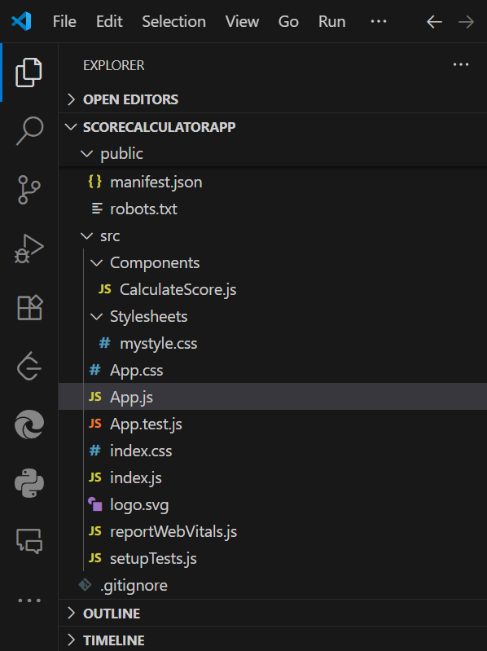

**App.js**

import { CalculateScore } from '../src/Components/CalculateScore';

function App() {

  return (

    <div>

      <CalculateScore

        Name="Alla Uma Yashaswi"

        School="Shri Vishnu Engineering College For Women"

        total={479}

        goal={500}

      />

    </div>

  );

}

export default App;

**Components/CalculateScore**

import '../Stylesheets/mystyle.css';

const percentToDecimal = (decimal) => {

    return (decimal * 100).toFixed(2) + '%';

};

const calcScore = (total, goal) => {

    return percentToDecimal(total / goal);

};

export const CalculateScore = ({ Name, School, total, goal }) => (

    <div className="formatstyle">

        <h1 style={{ color: 'brown' }}>Student Details:</h1>

        <div className="Name">

            <b><span>Name: </span></b>

            <span>{Name}</span>

        </div>

        <div className="School">

            <b><span>School: </span></b>

            <span>{School}</span>

        </div>

        <div className="Total">

            <b><span>Total: </span></b>

            <span>{total} Marks</span>

        </div>

        <div className="Score">

            <b>Score: </b>

            <span>{calcScore(total, goal)}</span>

        </div>

    </div>

);

**Stylesheets/mystyle.css**

#Name {

  font-weight: 300;

  color: blue;

}

#School {

  color: crimson;

}

#Total {

  color: darkmagenta;

}

.formatstyle {

  text-align: center;

  font-size: large;

}

.Score {

  color: forestgreen;

}

**Output:**

PS C:\Users\umaya\Desktop\-Cognizant-Nurture-4.0-practice\Week6\scorecalculatorapp> npm start

> scorecalculatorapp@0.1.0 start

> react-scripts start

(node:3008) [DEP_WEBPACK_DEV_SERVER_ON_AFTER_SETUP_MIDDLEWARE] DeprecationWarning: 'onAfterSetupMiddleware' option is deprecated. Please use the 'setupMiddlewares' option.

(Use `node --trace-deprecation ...` to show where the warning was created)

(node:3008) [DEP_WEBPACK_DEV_SERVER_ON_BEFORE_SETUP_MIDDLEWARE] DeprecationWarning: 'onBeforeSetupMiddleware' option is deprecated. Please use the 'setupMiddlewares' option.

Starting the development server...

Compiled successfully!

You can now view scorecalculatorapp in the browser.

Local: http://localhost:3000

On Your Network: http://192.168.140.50:3000

Note that the development build is not optimized.

To create a production build, use npm run build.

webpack compiled successfully

